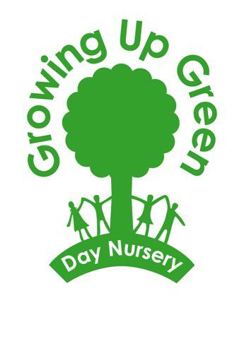

Quality childcare needn’t cost the earth
208 Preston Road, BN16RA
Email: info@growingupgreen.co.uk www.growingupgreen.co.uk
Contract for 15/30 hours Early Years Free Entitlement for two, three and four year olds
At Growing up Green the Early Years Free Entitlement is provided for 51 weeks of the year. 1140 hours if you are claiming the 30 hours and 561 hours if you are claiming the 15 hours. This starts the term after their 2nd birthday (Two year old funding) 3rd birthday (Three year old funding). If you are splitting the funding between more than one setting you must make us aware, this may affect the amount of funded hours you would be able to claim with us.

Growing up Green will offer the Early Years Free Entitlement (EYFE) hours free of charge.

EYFE Daily and sessional allowance

Numbers of hours allowed to be claimed over a session or a day are as follows:

Please note:
All Yellow hours are funded up to a maximum of 22 funded hours a week for the 30 hours and 11 funded hours per week for the 15 hours.
NO MORE than 9 EYFE hours can be claimed as a full day.
NO MORE than 4 hours can be claimed as a half day.
All additional hours will be charged at £12.00 per hour plus charges for snacks and lunches. (See snacks and lunches below)

Snacks and lunches
Snacks and lunches will be added as an extra charge; costs will be as follows:
£10 Full Day
£7 Morning Session
£4.50 Afternoon Session

- If you are joining us when your child is starting the funding you will need to pay a £100 deposit. Your deposit will be refunded to you when your child leaves the setting.

- You must provide the original of your child’s birth certificate or passport to be copied at the setting to be able to claim EYFE. Failure to do so will result in the withdrawal of the EYFE offer.

- We will offer two stand-alone afternoon sessions per day, depending on availability. We will advertise these places within the nursery when available. Please contact the office for more information.

- You must tell us if your child is going to be absent from nursery due to holidays or sickness. Prolonged unauthorised absence may result in your EYFE being withdrawn.

- One calendar months’ notice will be needed to terminate your contract.

- Changes to days need a minimum of one months’ notice.

- If for any reason your 30 hours is withdrawn and you are no longer eligible, you will be liable for any outstanding fees.

- If you would like to book in extra sessions they will be charged at normal nursery rates.

Full Day Chart
EYFE hours
Non funded hour. If you would like your child to attend this hour there will be a charge of £12.00 plus additional charge for food.

Hours | Monday | Tuesday | Wednesday | Thursday | Friday
8.00-9.00
9.00-10.00
10.00-11.30
11.30-12.30
12.30-1.00
1.00-2.00
2.00-3.00
3.00-4.00
4.00-5.00
5.00-6.00

Half a day session Chart
EYFE hours
Non funded hour. If you would like your child to attend this hour there will be a charge of £12.00 plus additional charge for food.

Hours | Monday | Tuesday | Wednesday | Thursday | Friday
8.00-9.00
9.00-10.00
10.00-11.30
11.30-12.30
12.30-1.00
Afternoon session is from 1pm-6pm
Non funded hour for afternoons is 2:30pm-3:30pm
We offer a limited amount of funded only/ stand-alone sessions in the afternoons (2 per day) on a first come first serve basis.
Please contact the office for more information.
Some examples are:
In a half-day session you can claim 4 EYFE hours and pay for 1 hour plus food.
In a full day you can claim 9 EYFE hours and you will pay for 1 hour plus food.
If you do not wish to pay for the additional hours or food you can collect your child at the end of your yellow funded sessions.

I confirm that I am parent/carer of …………………………………………………. and agree to adhere to the terms and conditions stated above.
Signature ………………………………………………………….. Date …………………………………….
Name (printed)………………………………………………….

